C PROGRAMMING TO GENERATE FIBONACCI SERIES WITH USING RECURSION

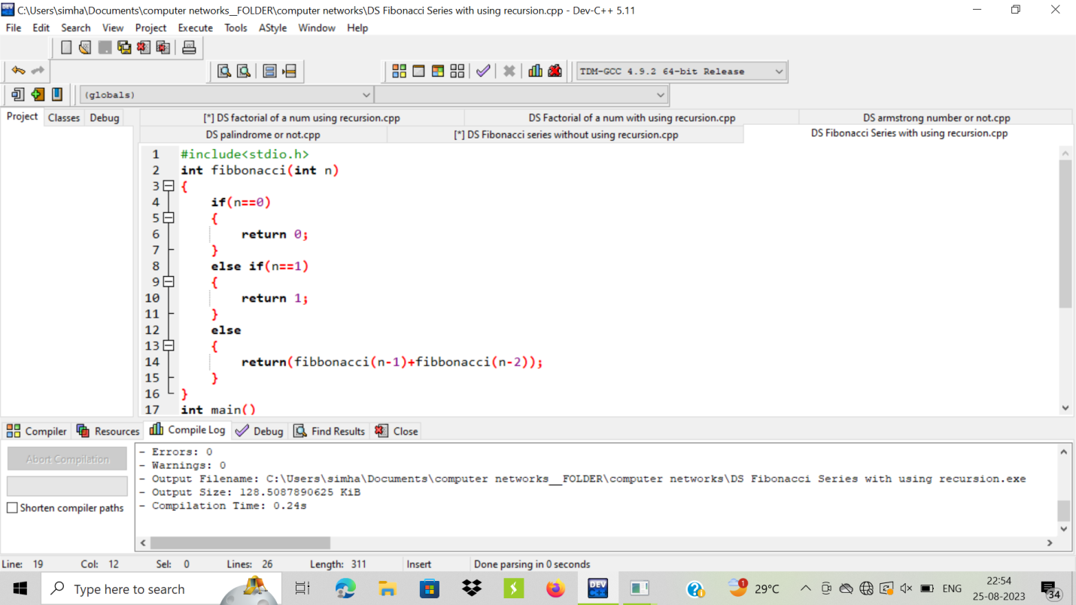

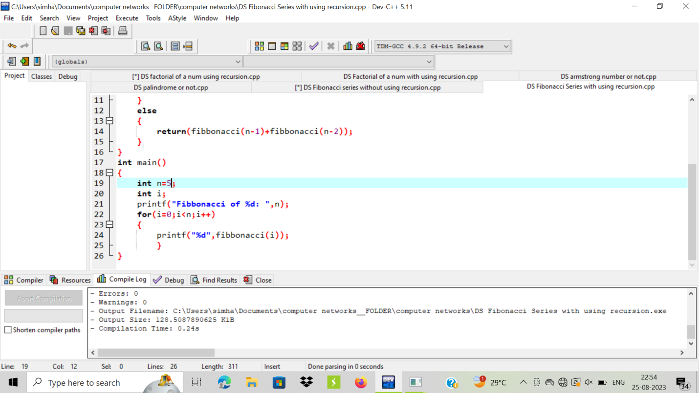

OUTPUT:

